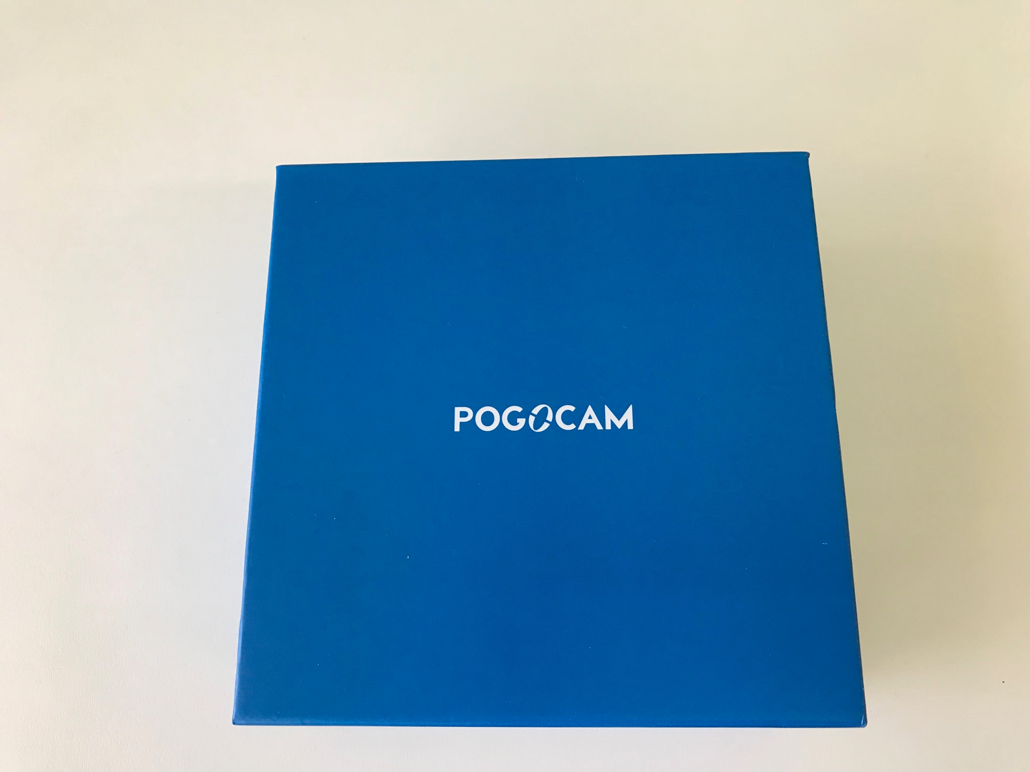
Eye To Eye Optical
Noble Manor Shopping Center
2350 Noblestown Road
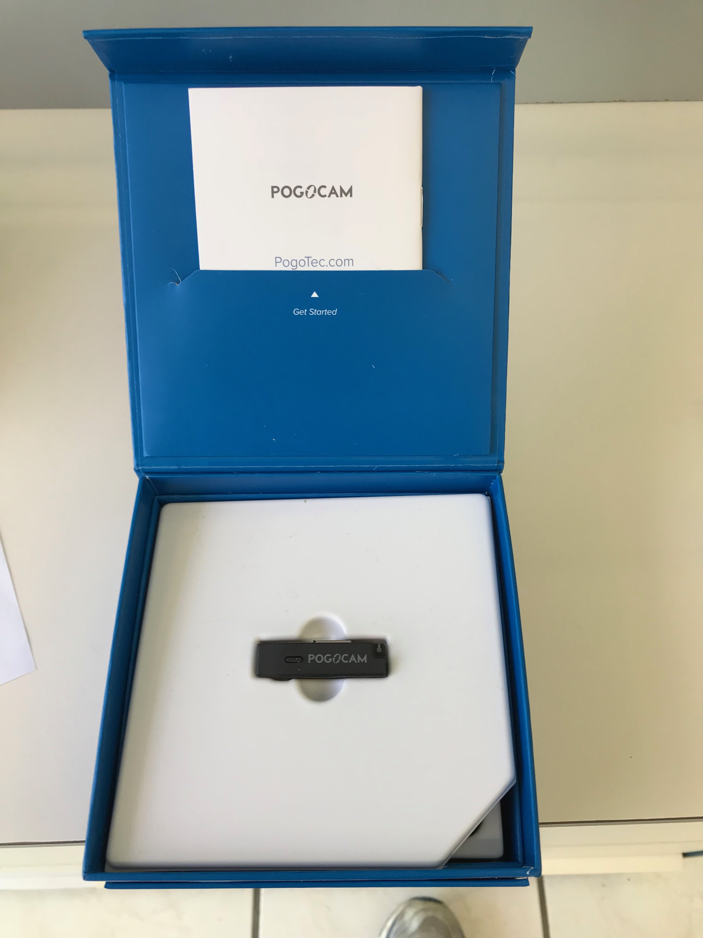
Pittsburgh, Pa. 15205
412-922-2606

POGO CAM

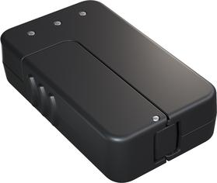Charge, store, & transfer
The included smart case charges PogoCam.
It also holds up to 16,000 photos or (180) 30-second videos.

Buy A Pair of Magnetic Glasses or

Use with your own glasses
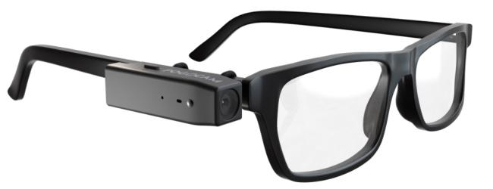
Cost only
$149
Included with PogoCam are three PogoLoop adaptors which slide over the arm of the glasses you already own to attach PogoCam magnetically.
The PogoCam has a 5-megapixel sensor and can store about 100 photos or two minutes of continuous 720p video.
You can share that footage anywhere you want to after you transfer to your computer -- Facebook, Twitter, Aunt Zelda's inbox, you name it.

